**Bellringer:** Membrane Protein Structure

AP Biology

Embedded proteins are often found spanning the membrane of a cell or organelle. These proteins serve as channels for specific molecules to travel through the membrane, either into or out of the cell.

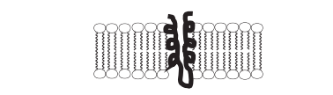

Using an arrow, **identify** the section(s) of the embedded protein chain that are most likely to contain amino acids with hydrophobic R-groups. **Explain** your reasoning.

Using an arrow, **identify** the section(s) of the embedded protein chain that are most likely to contain amino acids with hydrophilic R-groups. **Explain** your reasoning.

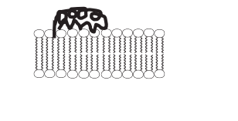

Some membranes have surface proteins on them. These proteins often serve a signaling function between cells. **Propose a mechanism** by which these surface proteins are able to attach to the membrane.